Forecasting Hierarchical Sales Models

Ian Frantz <www.ianfrantz.com>

2018-04-08

# What might be the sales results for Drift’s Product 1 - Tier 1?

IF:

* Trial 1 - For 52 weeks, Drift makes 1 sale per week.
* Trial 2 - For 1 Quarter, Drift makes 35 sales per week.

Hierarchical Sales Model

|  |  |  |  |  |
| --- | --- | --- | --- | --- |
| product_name | tier_name | offer_number | price | probability |
| Product 1 | Tier 1 | 1 | 0 | 0.25 |
| Product 1 | Tier 1 | 2 | 360 | 0.50 |
| Product 1 | Tier 1 | 3 | 1200 | 0.25 |
| Product 1 | Tier 2 | 1 | 0 | 0.50 |
| Product 1 | Tier 2 | 2 | 50 | 0.30 |
| Product 1 | Tier 2 | 3 | 100 | 0.20 |
| Product 2 | Tier 1 | 1 | 500000 | 0.05 |
| Product 3 | Tier 1 | 1 | 10000 | 0.30 |
| Product 3 | Tier 2 | 2 | 20000 | 0.70 |
| Service 1 | Tier 1 | 1 | 30000 | 0.40 |
| Service 1 | Tier 1 | 2 | 40000 | 0.60 |
| Service 2 | Tier 1 | 1 | 500000 | 1.00 |

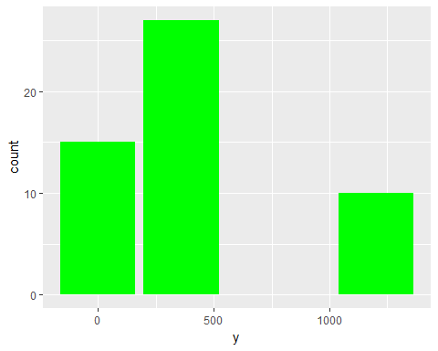

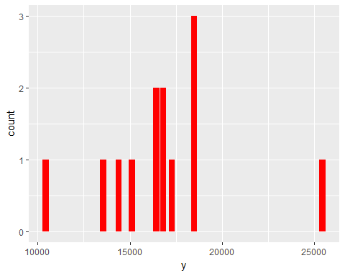

# ANSWER:

* For Trial 1 - $21720
* For Trial 2 - $218160

## Bonus: What do the combined results of tial1 and trial2 look like?

